INTERNATIONAL CONFERENCE ON JETS, WAKES AND SEPARATED FLOWS

Hiroshi TSUCHIDA, Masato AKIMOTO, Motoaki KIMURA*

Department of Mechanical Engineering
College of Science & Technology
Nihon University
Kanda Surugadai, Chiyoda-ku, Tokyo, Japan
*E-mail: kimura@mech.cst.nihon-u.ac.jp

Abstract
Papers will be selected on reviewing of abstracts. Your abstract should be in one A4 page and is used for classification of your topic to suitable techical tracks planned in the ICJWSF. The author(s) of accepted abstracts will be requested to submit a full paper of 4 pages or more (limited to 10 MB) later, which will be included in the electronic proceedings to be provided to all the registered participants. All the abstracts accepted will be included in the conference pamphlet to be distributed onsite to the participants during the conference.
The preferred style of the abstract for review: abstract should be in single column, A4 size (210 cm by 297 cm). The margins are, top 3.0cm, bottom 2.0cm, left 1.5cm and right 1.5cm. The text of main body is 11pt Times New Roman. The abstract should include the title of the paper, authors names and affiliations, a clear indication of the problem, method of approach, results and conclusions.
For easier assesment of your work by the track organizer(s), the one-page abstract should be very concise and informative. Please show the most representative figure(s) in this abstract such as experimental setup and typical result of measurement (see Figure 1). Also, please give several keywords at the bottom of the page. In the step of abstract submission, the number of words and fonts do not matter but the abstract must be printable in one-page.
Please submit the abstract prepared to the conference web site shown below according to the introduction of paper submission.
In the case of any specific inquiry, please contact the conference secrectary by e-mail: cst.icjwsf2022@nihon-u.ac.jp or by phone: +81-3-3259-0750.

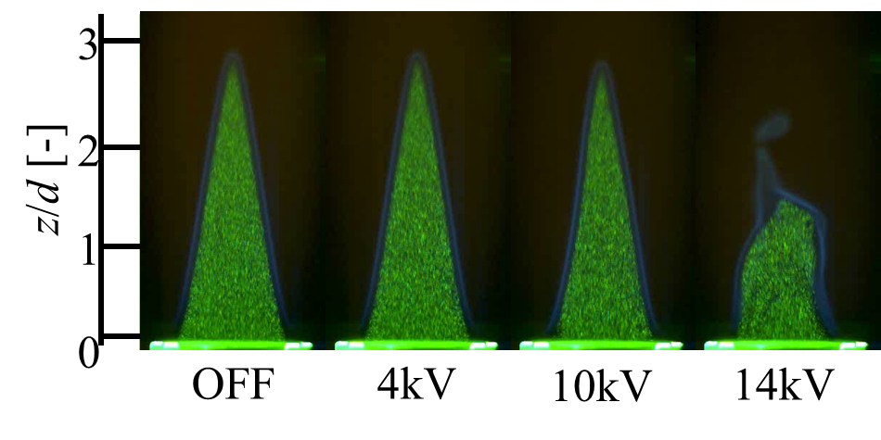
Figure 1 Flow Visualization in case of Case B (Flame Interior)

Keywords: DBD plasma actuator, premixed combustion, jet, flame visualization, flow visualization

